EENG 385 - Electronic Devices and Circuits

Lab 3 - Deboo Integrator

Lab Handout

# Objective

The objective of this lab is to introduce you to the operation of the Deboo Integrator and its interactions with 555 Timer and Schmitt Trigger Relaxation Oscillator to create a staircase voltage waveform.

# System Architecture

We are now in our third lab analyzing, modeling and constructing the various subsystems that make-up the BJT Curve Tracer shown in Figure 1. Today we will explore the Deboo Integrator, a circuit that integrates its input.

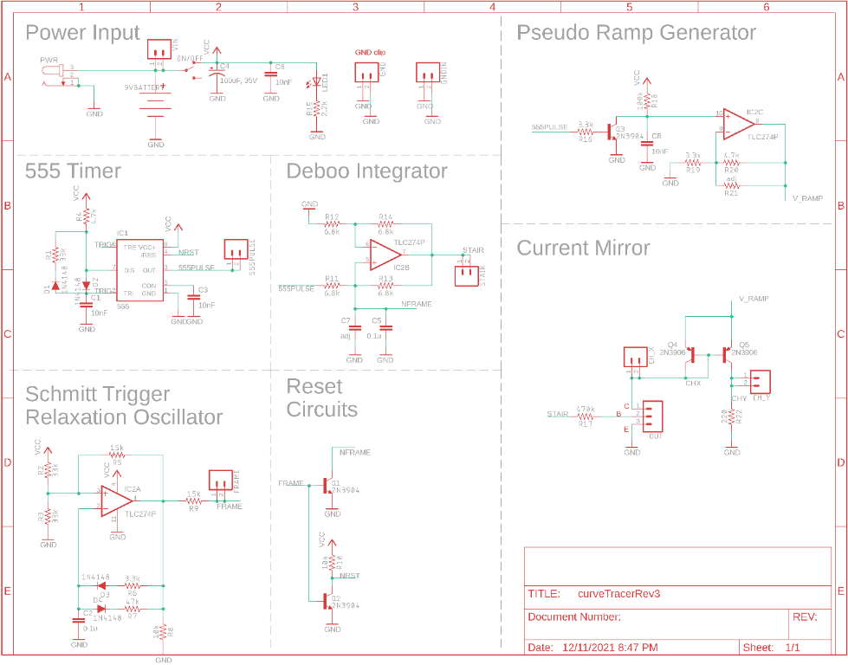

Figure : The complete BJT curve tracer.

Look carefully at the schematic shown in Figure 1 and located the Deboo Integrator subsystem. Now notice that two signals “555PULSE” and “NFRAME” in this subsystem originate in the 555 Timer and the Schmitt Trigger Relaxation Oscillator (via Reset Circuits) subsystems. In order to understand the behavior of the Deboo Integrator, you should review the behavior of these two subsystems. Do this by retrieving the simulation information you found in the previous two labs and putting this information into Table 1.

Table : The output of the 555 Timer and Schmitt Trigger Oscillator simulations from the prior two labs.

|  |  |  |
| --- | --- | --- |
| Quantity | 555 Timer Simulation | Schmitt Trigger Relax Osc Simulation |
| Time high (us) |  |  |
| Time low (us) |  |  |
| Period (us) |  |  |
| Frequency (kHz) |  |  |
| Duty Cycle |  |  |

We will come back to this table through the course of the lab.

# Analysis Deboo Integrator

The construction of a working BJT curve tracer requires that we create a staircase-shaped voltage waveform. A staircase waveform looks like, you guess it, a staircase when viewed from the side – you’ll see it later in the lab. The circuit to do this is a Howland Current Source with a capacitive load, called a Deboo Integrator. The Deboo Integrator you will build is shown in Figure 2. Note, in this circuit all the resistors have the same value, denoted as R.

# 

Figure : A Deboo Integrator integrates the input voltage over time.

# To understand how the Deboo Integrator computes the integral of the input voltage, let’s walk through the following analysis together.

1. Write an equation relating V- and Vout. Solve in terms of Vout. Hint, voltage divider.
2. Write an equation for Iout in terms of V+, Vout and R. Hint, use Ohm’s law.
3. Replace the Vout term in the step 2 equation with the value for Vout found in the step 1 equation.
4. Since the circuit has positive/**negative** feedback the inverting and non-inverting inputs of the op amp are the same. Let’s call this common voltage Vc. So V- = V+ = Vc.
5. Replace V+ and V- in the step 3 equation with Vc. Simplify.
6. Write an equation for Iin in terms of Vin, Vc and R. Hint, Ohm’s law.
7. Write a KCL equation for the V+ node.
8. Replace the Iout and In terms in the step 7 equation with the value for Iout/Iin found in the step 5/6 equation. Simplify. Hint, the simplified equation has three terms.
9. Write the equation for the current (called Ic) in a capacitor in terms of the voltage (called Vc) and capacitance.
10. Replace the Ic term in the step 9 equation with the value for Ic found in the step 8 equation.
11. Replace the Vc term in the step 10 equation with the value of Vc found in the step 1 equation (remember that V- equals Vc).
12. Multiply both side of the step 10 equation by dt/C and then integrate both sides.

This is pretty cool; we have a circuit that computes the integral of the input voltage, multiplied by 2/RC, and places it on its output. Let’s now look at how this capability is used to create a staircase voltage.

# Analysis Deboo Integrator in BJT Curve Tracer

The Deboo Integrator in the BJT Curve Tracer in Figure 1 is feed its input from the 555 Timer output (555PULSE in Figure 1). The next set of questions seeks to understand how the Deboo Integrator output will look like when it receives these pulses.

1. Using the values of resistance and capacitance in Figure 1, compute the weighting factor 2/RC for the Deboo Integrator output. Note we will not be including capacitor C7 in our design today. So ignore it in the analysis.
2. Assume that Vcc = 9V. Apply a single 555 Timer pulse from Table 1 to the Vin terminal of the Deboo Integrator. How much will Vout increase? Remember that the integral is the area under the curve and for the 555 Timer pulse, this is just the area of the rectangle formed by the pulse. Put this value in the Analysis column of Table 2 in the Analysis section at the end of the lab.
3. Assume that the Vout of the Deboo Integrator is initially at 0V as shown in the upper graph of Figure 3. The lower graph shows a sequence of pulses from the 555 Timer being applied to the input of the Deboo Integrator. Draw the resulting voltage vs. time graph of the Vout.

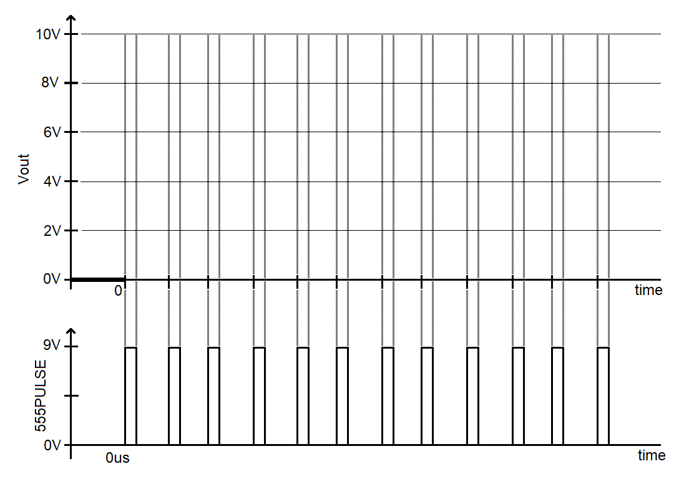

Figure : Complete the Vout curve that is generated by the Deboo Integrator circuit when the 555 pulse train is applied.

You would be right in concluding that the staircase function will reach Vcc after 9 steps. After this the op amp output will become saturated. We need is a way to periodically remove the charge from the capacitor. We will accomplish this using the Schmitt Trigger Relaxation Oscillator and the Q1 transistor shown in Figure 1.

**Resetting the Deboo Integrator Capacitor**

Before diving into the interactions between these modules, let’s take a moment to understand the behavior and purpose of the transistor. The 3-terminals of a transistor are called the collector (C), Base (B) and Emitter (E). The left-side of Figure 4 shows the schematic view of a transistor with these terminals labeled.

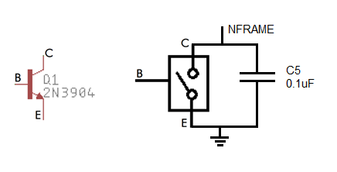

Figure : The schematic of a transistor and its equivalent circuit, for the BJT Curve Tracer.

We will reset the charge on the Deboo Integrator’s capacitor C5 by using the transistor as a voltage-controlled switch, shown on the right-side of Figure 4. The behavior of this switch is given by:

* When the base is driven towards 9V, the switch is closed. In other words, the collector and emitter are connected.
* When the base if driven towards 0V, the switch is open. In other words, the collector is disconnected from the emitter.

Take a moment and look for the Q1 transistor in Figure 1.

1. What circuit (subsystem name) is supplying the signal applied to the base of Q1?
2. During on period, how long is the FRAME signal at 0V and how long is FRAME at 9V?
3. About how many (integer)555 Timer pulses arrive at the input of the Deboo Integrator while the base of transistor, FRAME, is at 0V?

Now consider how this signal will affect the charge on the capacitor C5. Note we will not be including capacitor C7 in our design today. So ignore it in the analysis.

1. When the base of Q1 is driven towards 9V, what will happen to the capacitor C5? Will it be discharged or allowed to accumulate charge?
2. When the base of Q1 is driven towards 0V, what will happen to the capacitor C5? Will it be discharged or allowed to accumulate charge?

Now let’s put these ideas together into a picture of how the staircase waveform generated by the Deboo Integrator will look like in the simulator and when assembled.

1. Using the information, you calculated in this section, estimate about how long will the Deboo Integrator output will be saturated at 9v?

Now that you have a good understanding of how the Deboo Integrator works, let’s turn to simulating this circuit to check our analysis.

**Simulation Deboo Integrator**

Log into your MultiSim Live account and take a moment to verify that you have a premium account. If you do not, go to the **Setup a Multisim Live premium account** instructions in Lab 00 and do this now.

In order to more quickly build the circuit shown in Figure 5, you should start by opening either the Schmitt Trigger Relaxation Oscillators created in the previous labs. **Immediately rename the circuit so that you do not accidently overwrite your previous work**. I have not figured out how to merge two previous designs, so you will have to spend a few minutes adding in the other circuit elements. You may want to check that the Schmitt Trigger Relaxation Oscillator capacitor has an initial value and that you simulation uses this initial condition. Note that I provided the three probes with their respective test point with names and changed their color in order to make the simulation output more readable – make the 555TIMER test point a light color. Be mindful where you put the probes, their location is important.

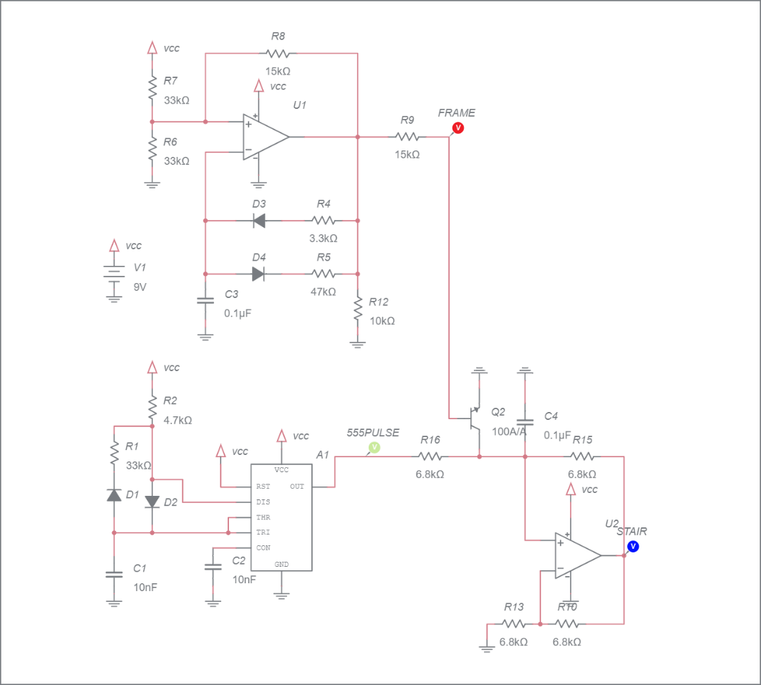

Figure : The Deboo integrator together with the 555-timer.

The parts list for the Deboo integrator is the same as for the Schmitt Trigger Relaxation Oscillator, you can reference the previous lab if you have difficulty finding the components.

After building the circuit, run the simulation for 20ms and include the simulated waveform with in your answers. To do this, make sure to Zoom All and use the Export -> Grapher image from the main menu to produce an output graphic.

Use the simulated staircase waveform to determine the step height; the amount that each 555-timer pulse increases the voltage on the Deboo Integrator output. Put this value in the Simulation column of Table 2 in the Analysis section at the end of the lab.

**Assemble Deboo Integrator**

This week, you will be soldering in the components in the Deboo Integrator area of the PCB shown in Figure 6. These components include:

* The components associated with the DEBOO INTEGRATOR subsystems,
* The Q1 transistor, a 2N3904,
* The STAIR test point.

For now, do not populate the C7 capacitor position. We may use this capacitor later to tune the step size so that the staircase waveform occupies the entire period of the Schmitt Trigger Relaxation Oscillator. More on this later.

This week, the transistor Q1 is the only polarized part. You will need to bend the leads on the BJT to fit the staggered holes of the PCB. Just make sure that the flat side of the BJT aligns with the flat side of the silk screen outline.

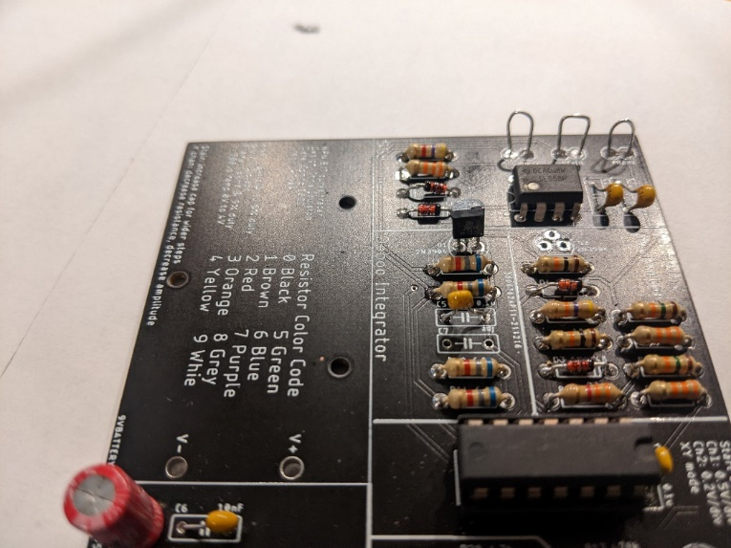

Figure : The completed (for lab 3) BJT Curve Tracer board.

After you solder in all the components you should test and correct any problems.

**Test Deboo Integrator Subsystem**

1. Check the resistance between the “+9V or higher” and “Gnd” test points with the ON/OFF switch in the OFF position. You should get an overload condition on the DMM – there is essentially infinite resistance with the switch in the OFF position.
2. Check the resistance between the “+9V or higher” and “Gnd” test points with the ON/OFF switch in the ON position. This measurement jumps around and may show negative resistance. The value displayed is not meaningful. You should not get a dead short.
3. Power up the BJT curve tracer:
   * Put the ON/OFF switch in the OFF position,
   * Apply power to the board either through your AC/DC converter or using the lab power supply. If you are using the lab power supply, set the voltage to 9V and the current to 100mA,
   * Throw the ON/OFF switch to the ON position,
   * The green LED should illuminate.
4. Power up an oscilloscope, attach a probe to Channel 1 and configure it as follows

|  |  |
| --- | --- |
| Ch1 probe | 555PULSE test point |
| Ch1 ground clip | GND test point |
| Horizontal (scale) | 1ms |
| Ch1 (scale) | 1V or 2V (whatever fits better) |
| Ch2 probe | STAIR test point |
| Ch2 (scale) | Same as Channel 1 |
| Trigger mode | Auto |
| Trigger source | Ch2 |
| Trigger slope | ↓ |
| Trigger level | 4.5V |

1. Set the GND reference of Ch1 and Ch2 to the lowest visible reticule – the waveforms will overlap the same that they did in the MultiSim simulation. Set the horizontal position of the trigger to the left most visible reticule. Screen shot this output and include in your lab report.

After you get everything setup, screen shot the 555PULSE and STAIR waveforms and include in your lab report. Use the data collected from the oscilloscope to determine the step height; the amount that each 555-timer pulse increases the voltage on the Deboo Integrator output. Put this value in the Assemble column of Table 2 in the Analysis section at the end of the lab.

**Debugging Deboo Integrator Subsystem**

I would expect most problems with this subsystem to be the result of:

* Bad solder connection
* Wrong component (resistor or capacitor)

If your BJT curve tracer board fails one of the test steps in the previous section, here is some guidance on what may have happened and how you can correct it.

1. If you are getting low resistance with the ON/OFF switch in the off position:
   * Make sure the ON/OFF switch is in the OFF position,
   * Make sure you are reading the DMM correctly.
2. If you are getting a different resistance with the ON/OFF switch in the on position:
   * Make sure the ON/OFF switch is in the ON position,
   * Make sure you are reading the DMM correctly. The reading when the ON/OFF switch in the ON position will jump around a lot and probably be negative.
3. If the green LED does not illuminate when power is applied ad the ON/OFF switch\ is in the on position:
   * Test that you are applying power. Put a DMM in voltage mode and check the +9V and Gnd test points.
   * Check for solder bridges on the read of the PCB.
4. If you are not getting waveforms that look like the MultiSim Live simulation.
   * Check that the board is powered up.
   * Check that the oscilloscope leads are fully inserted.
   * Press the “Default Setup’” button to undo any weird configuration that the last user may have left the oscilloscope in.
   * Check that solder connections by trying to wiggle each component. There should be no visible movement.

# Turn in:

Make a record of your response to numbered items below and turn them in a single copy as your team’s solution on Canvas using the instructions posted there. Include the names of both team members at the top of your solutions. Use complete English sentences to introduce what each of the

**Analysis Deboo Integrator**

Steps 1-12 of analysis

**Analysis Deboo Integrator in BJT Curve Tracer**

Steps 1-9 of analysis

**Simulation Deboo Integrator**

Schematic (use Export -> Schematic Image)

Timing diagram (use Export -> Grapher Image)

**Assemble Deboo Integrator**

Screen shot oscilloscope output for 555PULSE and STAIR.

**Overall Analysis Deboo Integrator**

Table : Summary of the step size calculations made for the Deboo integrator.

|  |  |  |  |
| --- | --- | --- | --- |
| Quantity | Analysis | Simulation | Assemble |
| Step size |  |  |  |

Complete the following table which lists the steps and their associated voltages. This will be helpful in lab 5.

|  |  |  |  |
| --- | --- | --- | --- |
| Steps | VSTAIR |  |  |
| 1 | 1.3V |  |  |
| 2 | 2.2V |  |  |
| 3 | 3.1V |  |  |
| 4 | 4.0V |  |  |
| 5 | 4.9V |  |  |
| 6 | 5.8V |  |  |
| 7 | 6.7V |  |  |
| 8 | 7.6V |  |  |